Project Planning Phase
Project Planning Template (Product Backlog, Sprint Planning, Stories, Story points)

Date | 04 July 2026
Team ID
Project Name | Cosmetic Insights: Navigating Cosmetics Trends and Consumer Insights with Tableau
Maximum Marks | 5 Marks

Product Backlog, Sprint Schedule, and Estimation (4 Marks)
Use the below template to create product backlog and sprint schedule
Sprint | Functional Requirement (Epic) | User Story Number | User Story / Task | Story Points | Priority | Team Members
Sprint-1 | Data Collection | USN-1 | As a user, I can collect cosmetic product data from Excel dataset | 2 | High | Person 1
Sprint-1 | Data Preprocessing | USN-2 | As a user, I can clean and validate the cosmetic dataset | 2 | High | Person 2
Sprint-2 | Data Analysis | USN-3 | As a user, I can analyze cosmetic brands, prices, and categories | 2 | Low | Person 3
Sprint-2 | Visualization | USN-4 | As a user, I can create charts and visualizations in Tableau | 3 | Medium | Person 4
Sprint-3 | Dashboard Creation | USN-5 | As a user, I can create interactive dashboards | 3 | High | Person 2
Sprint-4 | Story Creation | USN-6 | As a user, I can create Tableau stories for insights | 2 | Medium | Person 1
Sprint-4 | Publishing | USN-7 | As a user, I can publish dashboards and stories in Tableau Public | 1 | High | Person 5
Sprint-5 | Documentation | USN-8 | As a user, I can prepare project documentation and presentation | 2 | High | Person 5

Project Tracker, Velocity & Burndown Chart: (4 Marks)
Sprint | Total Story Points | Duration | Sprint Start Date | Sprint End Date (Planned) | Story Points Completed (as on Planned End Date) | Sprint Release Date (Actual)
Sprint-1 | 4 | 6 Days | 29 Jun 2026 | 30 Jun 2026 | 4 | 30 Jun 2026
Sprint-2 | 6 | 6 Days | 30 Jun 2026 | 1 July 2026 | 6 | 1 July 2026
Sprint-3 | 4 | 6 Days | 01 July 2026 | 2 July 2026 | 4 | 2 July 2026
Sprint-4 | 3 | 6 Days | 02 July 2026 | 3 July 2026 | 3 | 3 July 2026

Velocity:
Imagine we have a 10-day sprint duration, and the velocity of the team is 20 (points per sprint). Let’s calculate the team’s average velocity (AV) per iteration unit (story points per day)

Burndown Chart:
A burn down chart is a graphical representation of work left to do versus time. It is often used in agile software development methodologies such as Scrum. However, burn down charts can be applied to any project containing measurable progress over time.

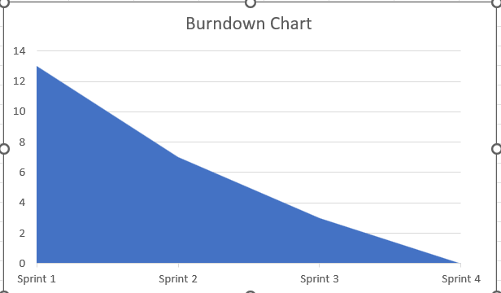

https://www.visual-paradigm.com/scrum/scrum-burndown-chart/
https://www.atlassian.com/agile/tutorials/burndown-charts

Reference:
https://www.atlassian.com/agile/project-management
https://www.atlassian.com/agile/tutorials/how-to-do-scrum-with-jira-software
https://www.atlassian.com/agile/tutorials/epics
https://www.atlassian.com/agile/tutorials/sprints
https://www.atlassian.com/agile/project-management/estimation
https://www.atlassian.com/agile/tutorials/burndown-charts

